**Gemini AI integration with Pega**

**Gemini AI is invented by Google**

**Google Gemini AI is a family of large language models currently capable the most capable AI models Google has developed**

**Here is a quick overview**

**Key Features-**

**MultiModal- Gemini can seamlessly understand and respond across different formats like text, code, images, and audio, unlike most AI models that focus on just one modality**

**Versatile- Available in three sizes(Ultra, Pro, Nano) to handle tasks ranging from complex research to efficient on device applications.**

**Safe- Extensive safety checks for bias, toxicity, and other potential risks.**

**Accessible- Developers and businesses can access Gemini Pro through Google AI Studio(free) or Vertex AI (paid, more features).**

Now let’s integrate this with Pega

Gemini AI integration with Pega

In order to integrate Gemini AI we need to get the developer console of google provided Gemini AI website.

Website- <https://ai.google.dev/?utm_source=google&utm_medium=cpc&utm_campaign=brand_core_brand&gad_source=1>

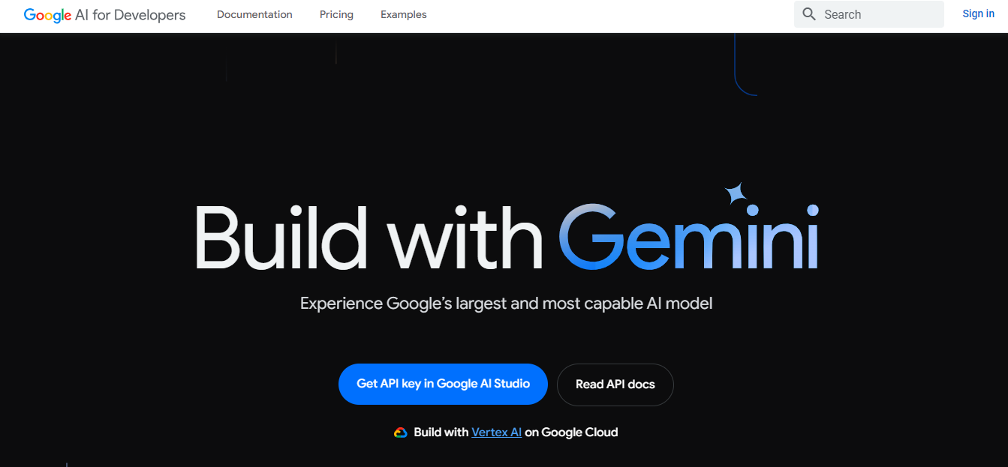

Then we need to click on the Get API key in Google AI studio and then need to accept all the terms and conditions.

Then click on Continue and after that click on Get API key

Then click on Create Api key in New Project

Then open web postman and paste the URL

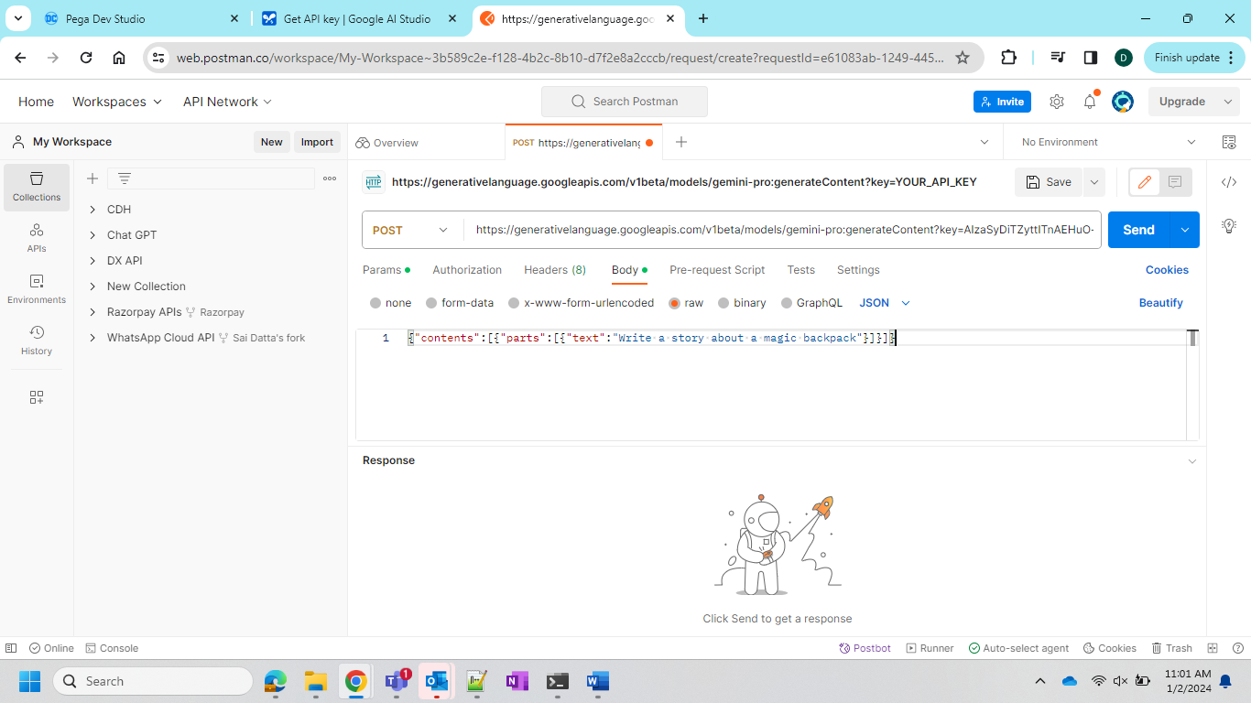

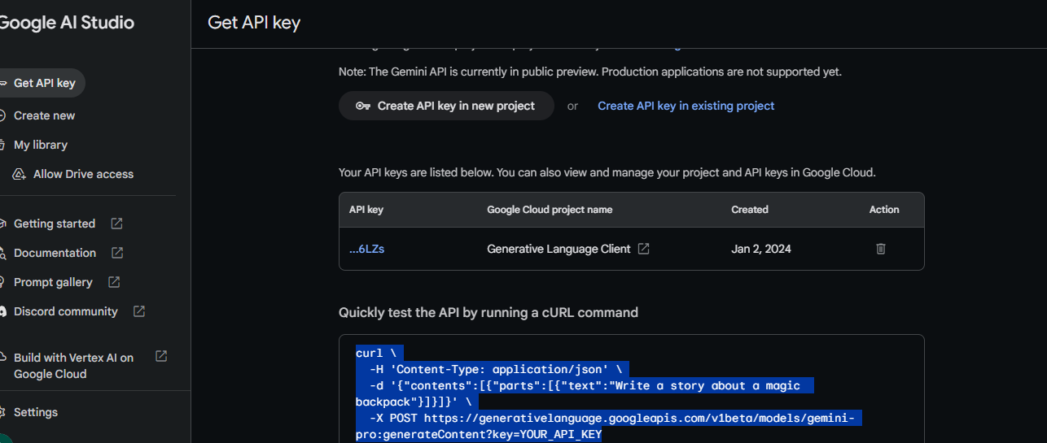

And then we need to go the postman and paste it and in place of API key we need to replace it with the present key that is generated within your project

Now get into postman and test your response

Now since the response is success we need to get into the dev studio and create integration REST

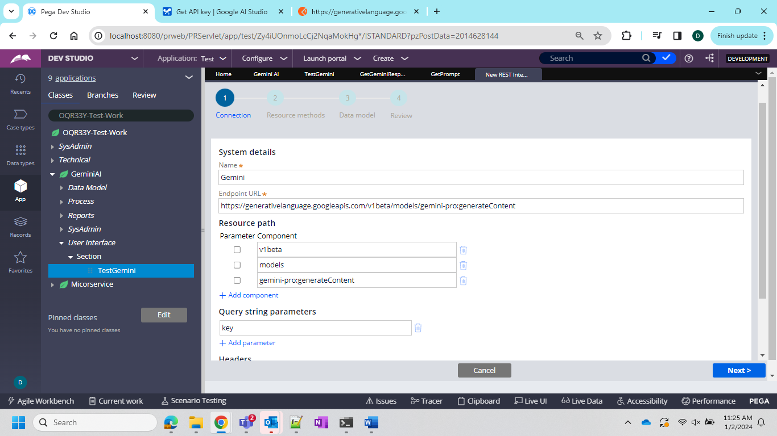

And after this you need to create an activity as follows

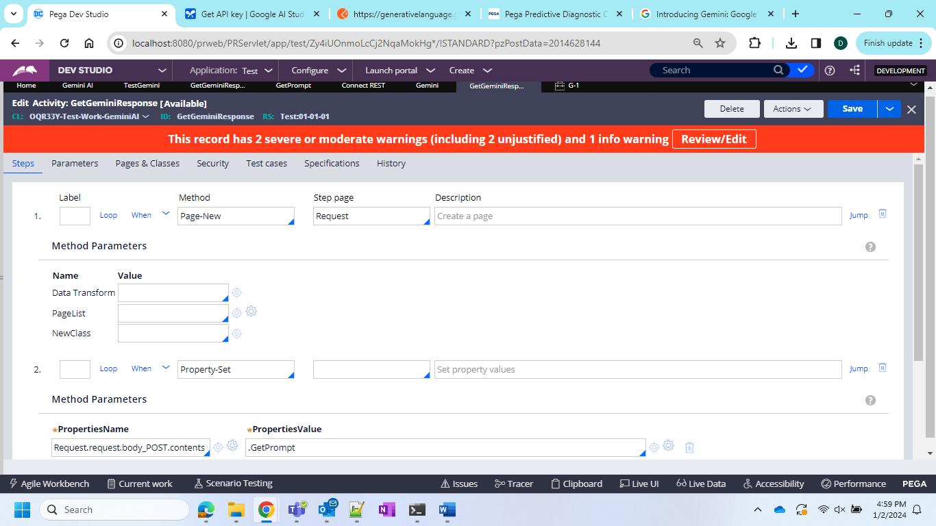

Now use this activity in the button of the section to generate the results and now lets run and see the results in Pega and postman both.

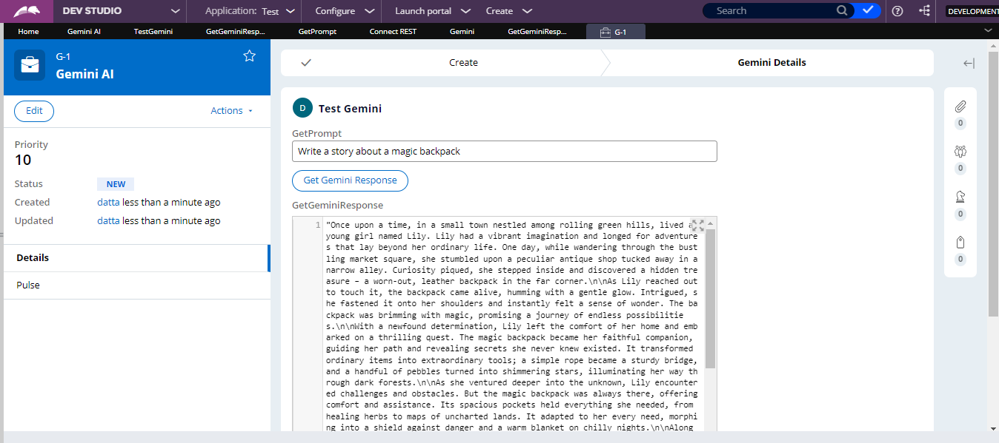

Pega Result

Postman result